umath.py | mtest1.py
def isprime(num):  c=0  for i in range(1,num+1):  if num%i==0:  c=c+1  return c==2  def factorial(num):  if num==0:  return 1  else:  return num*factorial(num-1)  def sumofdigits(num):  s=0  while num>0:  d=num%10  s=s+d  num=num//10  return s | import umath  x=umath.isprime(5)  y=umath.isprime(6)  print(x,y)  f1=umath.factorial(4)  f2=umath.factorial(5)  print(f1,f2)  res1=umath.sumofdigits(123)  res2=umath.sumofdigits(5678)  print(res1,res2)

Syntax-2: import module-name as alias-name

This syntax allows importing module with another name or alias name. if any other name in current module with same name, to avoid conflict we use alias name. it is also used for giving shorter names.

Authentication.py | Mtest2.py
users={'naresh':'n123',  'suresh':'s321',  'ramesh':'r567'}  def login(u,p):  if u in users and users[u]==p:  return True  else:  return False | # Login Application  import authentication as au  username=input("UserName :")  password=input("Password :")  if au.login(username,password):  print(f'{username} welcome')  else:  print("invalid username or password")

Syntax-3: from module-name import *
This allows importing module content as a part of current module.

Transaction.py | Atm.py
customers={1:['naresh',45000],  2:['suresh',54000],  3:['ramesh',65000]}  def deposit(a,t):  if a in customers:  customers[a][1]=customers[a][1]+t  return True  else:  return False  def withdraw(a,t):  if a in customers:  if customers[a][1]>t:  customers[a][1]=customers[a][1]-t  return True  else:  return False  else:  return False  def findbal(a):  if a in customers:  return customers[a][1]  else:  return False | # ATM  from transaction import *  while True:  print("1.Deposit ")  print("2.Withdraw")  print("3.FindBalance")  print("4.Exit")  opt=int(input("Enter Your Option :"))  match opt:  case 1:  accn=int(input("AccountNo :"))  t=int(input("Amount :"))  if deposit(accn,t):  print("Transaction Completed")  else:  print("Error in transaction")  case 2:  accn=int(input("AccountNo :"))  t=int(input("Amount :"))  if withdraw(accn,t):  print("Transaction Completed")  else:  print("Error in transaction")  case 3:  accn=int(input("AccountNo :"))  b=findbal(accn)  if b==False:  print("Invalid Accountno")  else:  print(f'Balance is {b}')  case 4:  break

Syntax-4: from module-name import identifier,identifier,…

This syntax allows to use specific identifiers imported from module as part of current module.

Module3.py | Mtest3.py
def fun1():  print("this is fun1")  def fun2():  print("this is fun2")  def fun3():  print("this is fun3") | from module3 import fun2,fun1  fun2()  fun1()

Syntax-5 : from module-name import identifier-name as aliasname
This syntax allows to import identifier names with another name or alias name.

Module3.py | Mtest3.py
def fun1():  print("this is fun1")  def fun2():  print("this is fun2")  def fun3():  print("this is fun3") | from module3 import fun2,fun1 as f1  def fun1():  print("this is fun1 of current module")  fun1()  f1()

What is __pycache__ folder?
This folder is automatically created by python runtime system.
This folder contains pre-compiled module (.pyc)
Before importing module, it is compiled and stored inside pycache folder.
Imported module not compiled every time before importing. It is compiled once and stored inside __pycache__ folder.

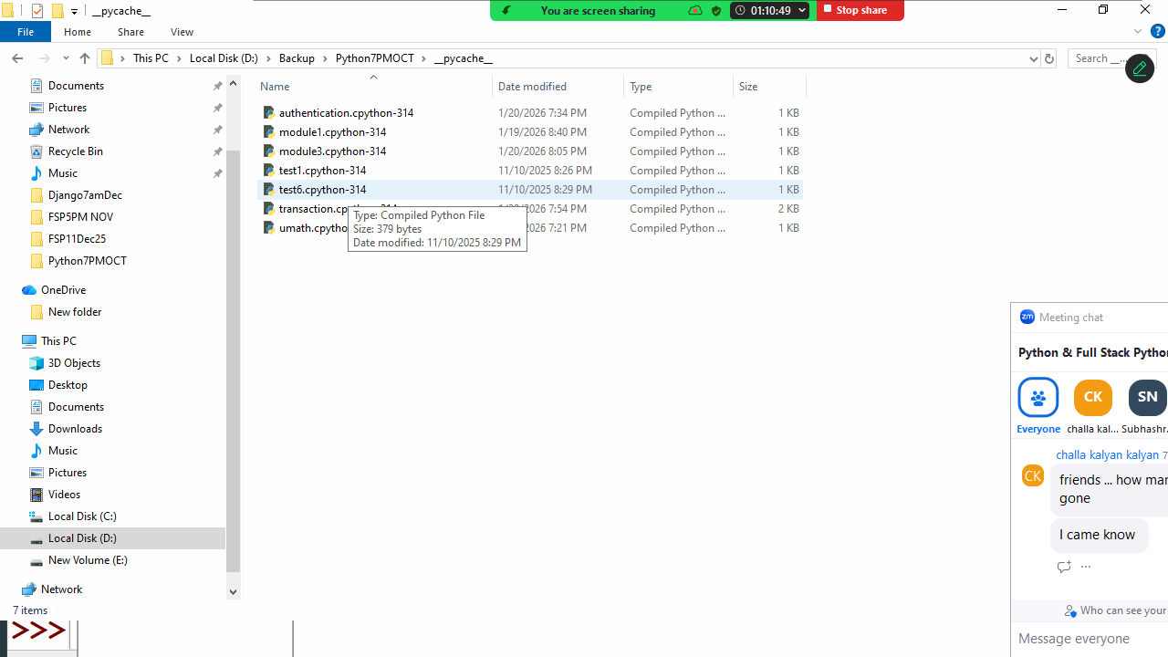

Package

What is package?
A package is collection of modules (.py)
A package is folder which contains .py files.
Packing is nothing but grouping related modules inside one folder (package).

How to create package?
Creating package is nothing but creating folder.
To recognize this folder as package, it contains one special module __init__.py

Basic steps for creating package
- Create folder
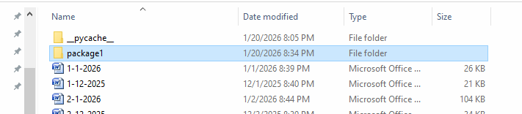
- Inside folder create a module with __init__.py
This is empty module.
It is called package configuration module or file.

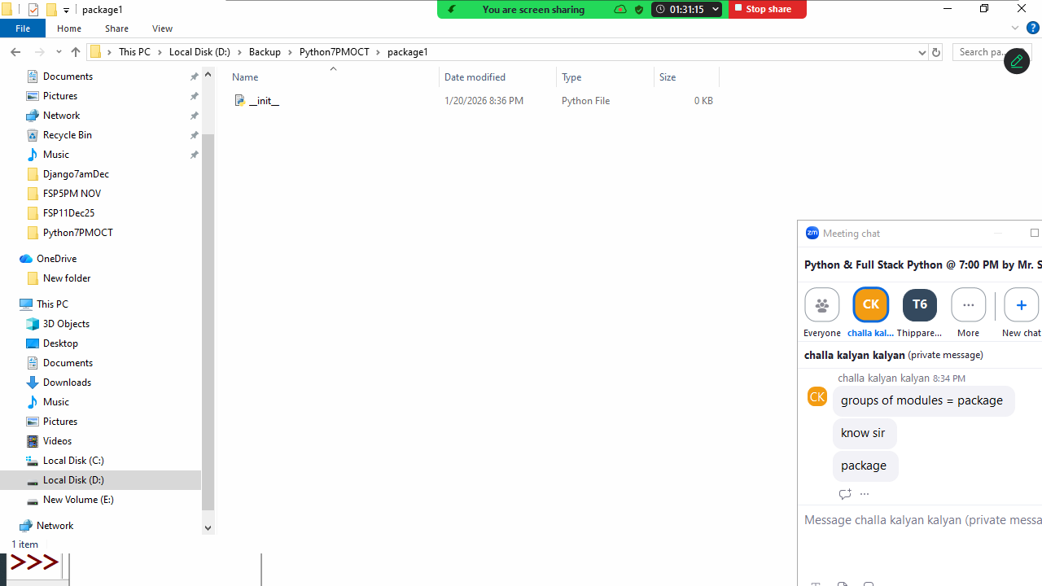
- Add another module inside package m1.py

m1.py
x=100
def fun1():
print("fun1 of m1 of package1")
def fun2():
print("fun2 of m1 of package1")

- Import m1 module outside the package. Create one module outside the package for testing

import package1.m1

package1.m1.fun1()
package1.m1.fun2()

